**QUIZ RESULTS**

**MODULE1: INTRODUCTION TO SUPERVISED MACHINE LEARNING AND LINEAR REGRESSION**

|  |  |  |  |  |
| --- | --- | --- | --- | --- |
| **No.** | **Quiz title** | **Completion Status** | **Score** | **Coursera link** |
| 1 | Module1_Practice Quiz_ Linear Regression | Completed | 100% | [Quiz 1](https://www.coursera.org/learn/supervised-machine-learning-regression/assignment-submission/IABxI/practice-quiz-linear-regression) |
| 2 | Module1_Practice Quiz_ Introduction to Supervised Machine Learning | Completed | 100% | [Quiz 2](https://www.coursera.org/learn/supervised-machine-learning-regression/assignment-submission/Sk0Ze/practice-quiz-introduction-to-supervised-machine-learning) |
| 3 | Module1_Introduction to Supervised Machine Learning and Linear Regression | Completed | 100% | [Quiz 3](https://www.coursera.org/learn/supervised-machine-learning-regression/assignment-submission/JyC8m/module-1-graded-quiz-introduction-to-supervised-machine-learning-and-linear) |

# Module1_Practice Quiz_ Linear Regression

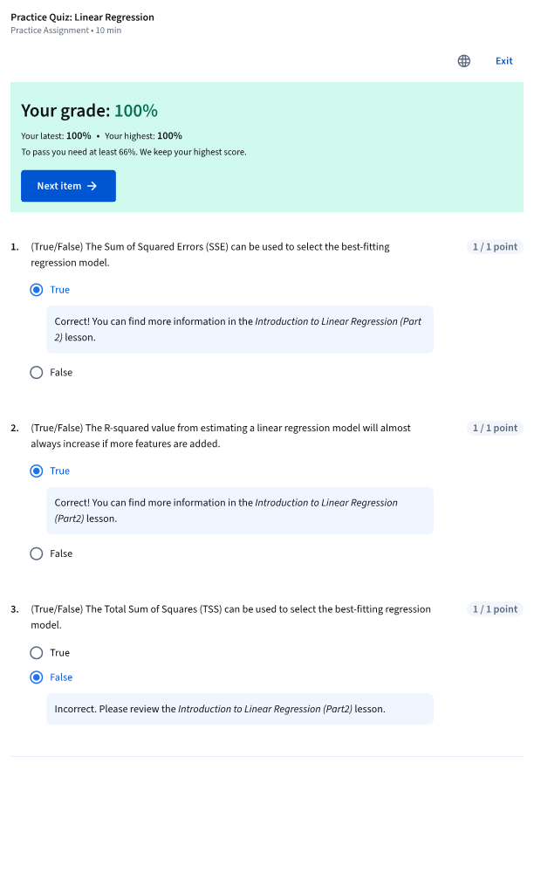

# Module1_Practice Quiz_ Introduction to Supervised Machine Learning

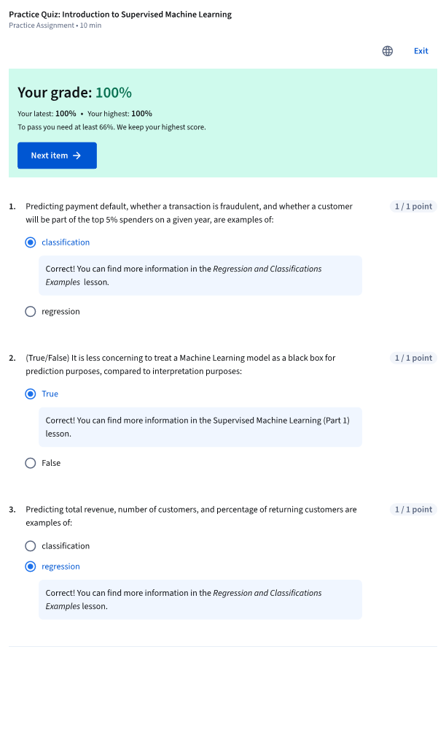

# Module1_Introduction to Supervised Machine Learning and Linear Regression

